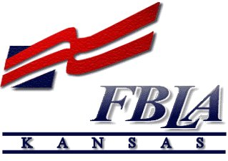Future Business Leaders of America
Connie Lindell, State Adviser
• 3920 Sophora Street •
Lawrence, KS 66049-7815
• cell (785) 760-1038 •
conniefbla@gmail.com

November 5, 2019

SUBJECT: 2020-2021 KS-FBLA State Officer Application information

To apply for a Kansas FBLA State Officer position, you must complete and email or mail the following items by of before December 16, 2019:

1) letter of application (refer to the box below for address and how to ‘address’ the letter)
2) resumé with objective (limit to two pages)
3) application form, that includes signatures from candidate, adviser, parent, administration
4) completed Quiz/Test over FBLA information (for District VP candidates only, unless you have completed the FUTURE Level of the BAA’s)

The above items can be delivered personally delivered, emailed, or must be postmarked by or before:
Monday, December 16, 2019

The Letter of Application must be addressed to:

Current date

Ms. Connie Lindell, State Adviser
Kansas FBLA
3920 Sophora Street
Lawrence, KS 66049-7815

Dear Ms. Lindell
When applying for an office, you may want to check your calendar to see if you are available to attend the following events in 2020-2021:

- State Officer Interview Saturday, January 4, 2020, Eudora High School, Eudora, KS * Required attendance for candidate & adviser!
- 2020 District Conference—required attendance, especially if you are a District VP candidate
- 2020 State Leadership Conference March 29-March 31, Topeka *
- State Board meeting, April 24-25, 2020 Topeka *
- CTSO State Officer Training, May 31-June 2, 2020 Junction City, Kansas *
- June 29-July 2, 2020—National Leadership Conference, Salt Lake City, UT *
- Summer Leadership Seminar (SLS)—July 20-21, 2020 TBA *
- State Board Meeting, September 19, 2020, Emporia *
- NFLC, Omaha—November 6-7, 2020 or Dallas, Texas—November 13-14, 2020
- State Officer Interview Saturday, January 9, 2021 (TBA) *
*required attendance

Please contact me: conniefbla@gmail.com (785) 760-1038 (cell) if you have any questions.

