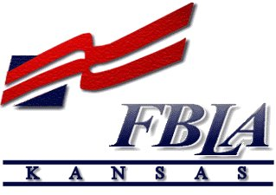Future Business Leaders of America
Connie Lindell, State Adviser
• 3920 Sophora Street •
Lawrence, KS 66049-7815
• (785) 760-1038 •
conniefbla@gmail.com

November 2, 2021

SUBJECT: 2022-2023 KS-FBLA State Officer Application information

To apply for a Kansas FBLA State Officer position, you must complete and email or mail the following items by of before December 15, 2021:

1) letter of application (refer to the box below for address and how to ‘address’ the letter)
2) resumé with objective line (limit to two pages)
3) application form, that includes signatures from candidate, adviser, parent, administration
4) completed Quiz/Test over FBLA information (for District VP candidates only, unless you have completed the FUTURE or Contributor Level of the BAAs)
5) picture of candidate in business attire. A ‘head & shoulders’ picture will work.
**Parliamentarian candidates only need to complete the application form

The above items can be emailed, or mailed and must be postmarked by or before:
Wednesday, December 15, 2021

The Letter of Application must be addressed to:
2” Top Margin before Dateline
Current date

Quad Space after Dateline
Ms. Connie Lindell, State Adviser
Double Space before & after; SS paragraphs of letter; DS between, don’t forget to SIGN your letter.
Kansas FBLA
3920 Sophora Street
Lawrence, KS 66049-7815

Dear Ms. Lindell
When applying for an office, you may want to check your calendar to see if you are available to attend the following events in 2022-2023:

- State Officer Interview Saturday, January 8, 2022, Herington HS, Herington, KS * Required attendance for candidate & adviser! Depending on weather & COVID, a ZOOM possibility could be offered.
- 2022 District Conference—required attendance, especially if you are a District VP candidate
- 2022 State Leadership Conference March 30-April 1, Topeka *
- State Board meeting, April 22-23, 2022 Topeka *
- CTSO State Officer Training, June 5-7, 2022, location TBA *
- June 29-July 2, 2021—National Leadership Conference, Chicago, IL *
- Summer Leadership Seminar (SLS)—July 25 or 26, 2022 TBA *
- State Board Meeting, September 17, 2022, Emporia *
- NFLC, Conferences—Locations TBA November 4-5, 11-12, or 18-19, 2022
- State Officer Interview Saturday, January 7, 2023 (TBA) *
*required attendance

Please contact me: conniefbla@gmail.com (785) 760-1038 (cell) if you have any questions.

