ADVISER QUICK GUIDE TO my.FBLA

The adviser is instrumental in organizing and stimulating chapter development. The local chapter adviser should:

- Be knowledgeable about the history, mission, and programs of the national organization for active operation of the local chapter.
- Direct, chaperone, and coordinate supervision of chapter activities.
- Organize the selection process for chapter officers and provide officer training.
- Encourage civic responsibility.
- Assist in the maintenance of necessary chapter records.
- Establish rules and guidelines that will help students lead themselves while remaining consistent with school policies and state and national bylaws.
- Hold regular chapter meetings and see that they are conducted in a business-like manner.
- Assist members and officers in developing an annual program of work, which includes a budget, calendar, and committee assignments.
- Assist members in planning, collecting, preparing, and arranging materials to promote the chapter and its activities.
- Ensure school administrators, faculty, students, and the public are informed of chapter activities and outstanding student achievements.
- Be knowledgeable of the guidelines for district/regional, state, and national competitive events and activities and coordinate participation at all levels.
- Oversee financial development projects and supervise the receipt, recording, depositing, and expenditure of chapter funds.
Logging In
- Go to www.fbla-pbl.org (FBLA-PBL National Website)
- Scroll to the bottom of the page or go to Advisers Tab > Chapter Management
- Click on my.FBLA

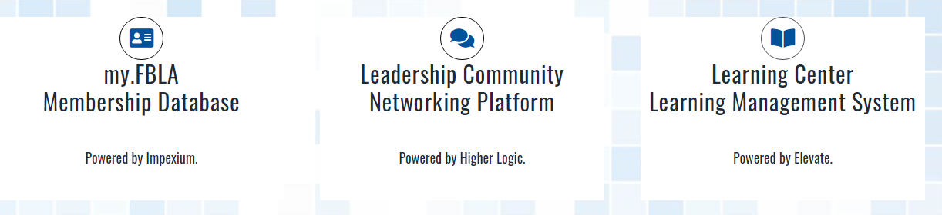

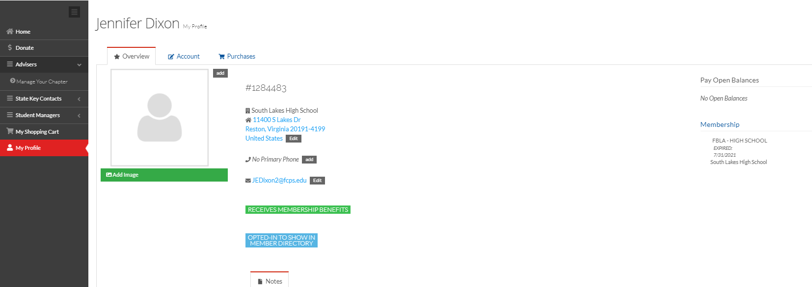
Click on Advisers and Manage Your Chapter.

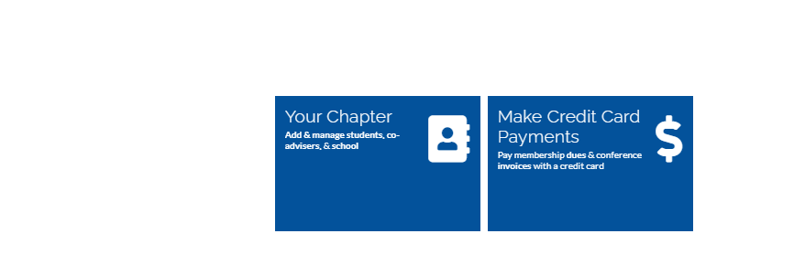

Click on Your Chapter. Most of what you will do will be in this area. This area includes:

- School/Chapter Information including charter date.
- Let’s you add or remove advisers, principals and student managers.
- Let’s you manage your chapter roster.
- Let’s you view paid and unpaid students.

See page 3 for a visual of the chapter profile.

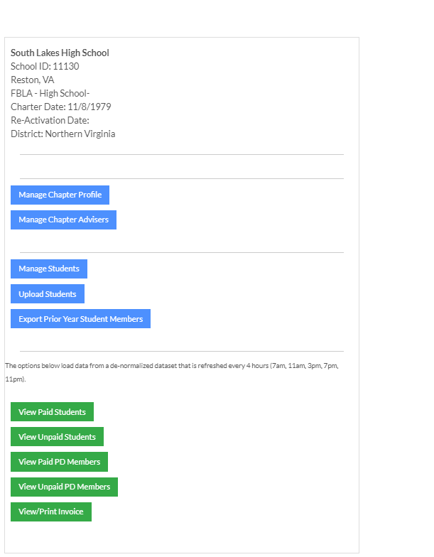
View paid and unpaid students (these will update every four hours)

veery four hours
Manage Your Chapter Roster
Add/Remove Chapter Advisers, Principals, Student Managers
View Chapter Information.
View/Edit School Information.

Registering Student Members
Log in
- Use your email address and password
- If you don’t have a password Click here to reset your password
- On the left side of the screen select Adviser Portal>Manage Chapter
- Select the Your Chapter App

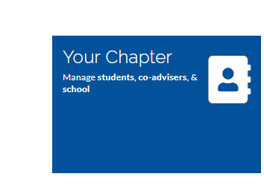

Click on Join/Renew Your AZ or CA FBLA/ML Chapter

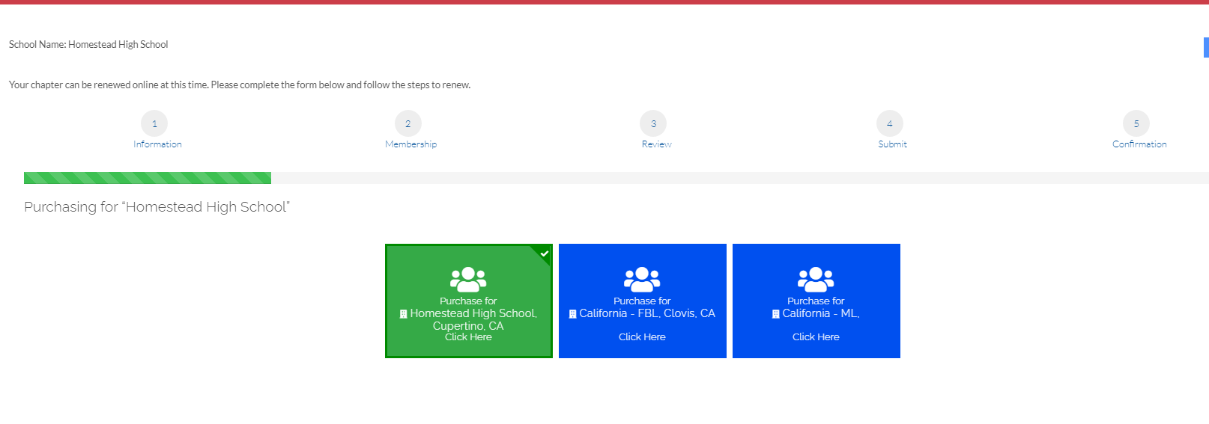
Click on Purchase for Your High School

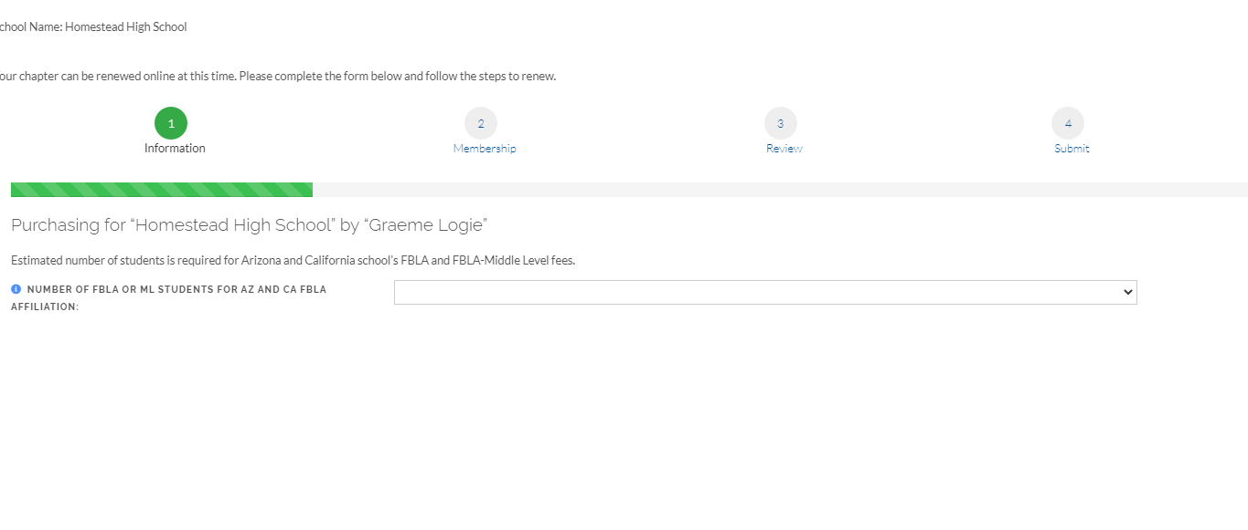
Choose your tier from the drop down and click on Next
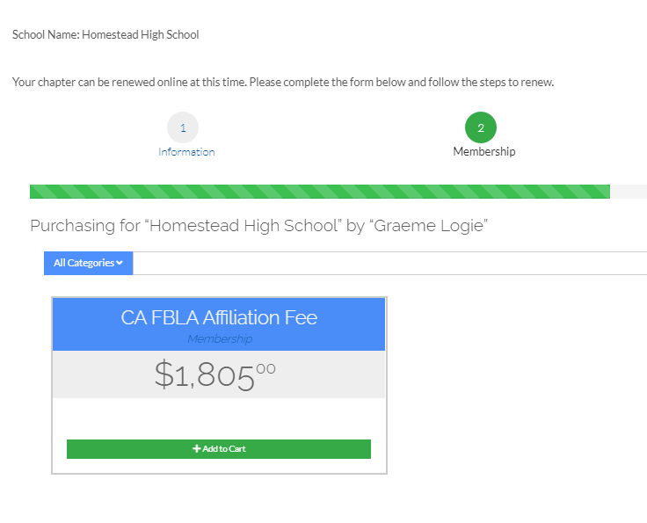
Click on Add to Cart Review and then Review and check out Check Out. Click On Check Out and then Bill Me or Credit Card and Submit Order.

Selecting Returning Student Members

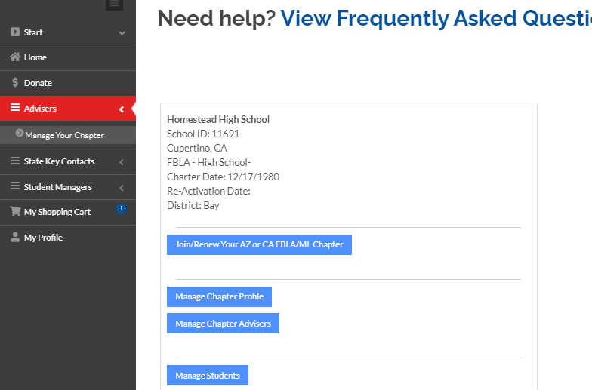
Click on Manage Students
Click on Manage Your Chapter

Manage your Roster. Keep anyone who is a student for this year listed and remove any student that will not be a member.

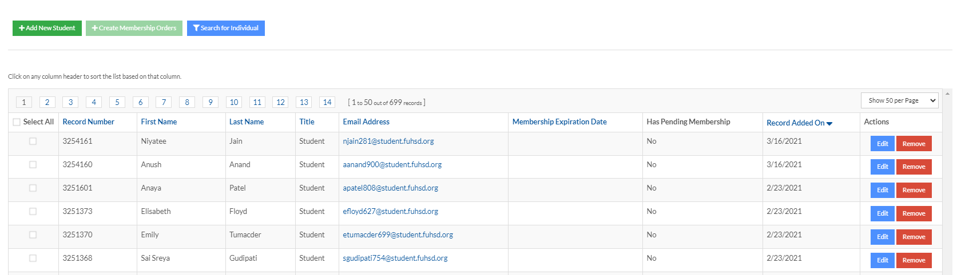

Click on Remove for ay student that will not be a member this year. This is how you manage your roster. Once you click on Ok when it asks are you sure you want to remove the record, the student is removed from this year’s roster. Be sure to click on edit for the students you keep and update the grade level.

Selecting New Members

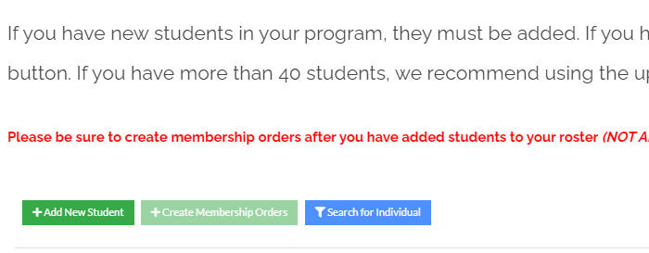

Click on Add New Student

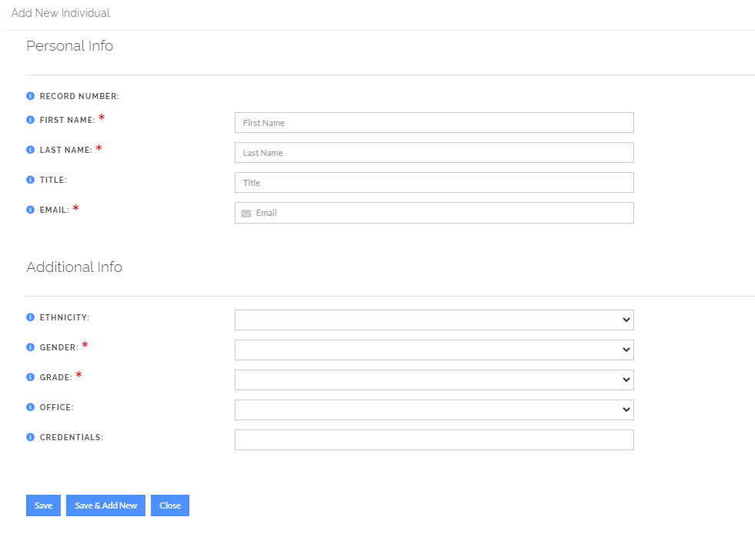
Type in required fields: First Name, Last Name, Email, Grade, and Gender. If you want, you may add ethnicity and office. If this is the only new student, click on save. If you have additional students, click on save and add new. When you are done adding all students, click on save.

Printing an Invoice

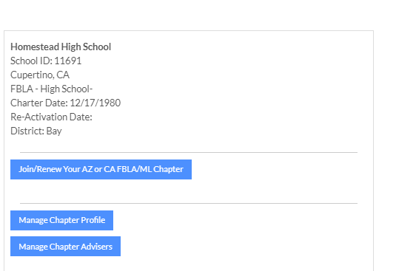
Click on Manage Chapter Profile

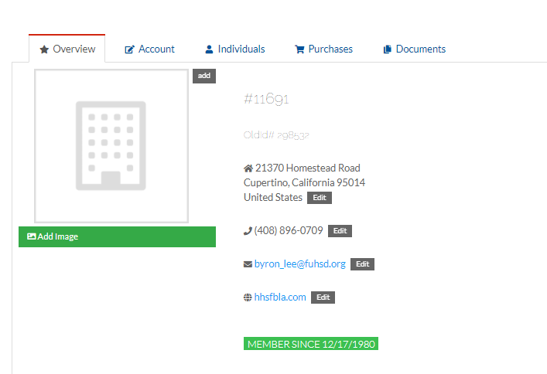
Click on Purchases. Click on Recent Invoices then View and Print

Adding a Website, Social Media Site, etc.

- Click On Manage Chapter Profile
- Click on Account.
- Click on Contact Information.
- Click on View Web Links and add links to Chapter Blog, Facebook, Website, etc.
- Addresses, phone numbers, and email addresses can also be changed in this area. Just click on the top tabs, make your changes, and save.

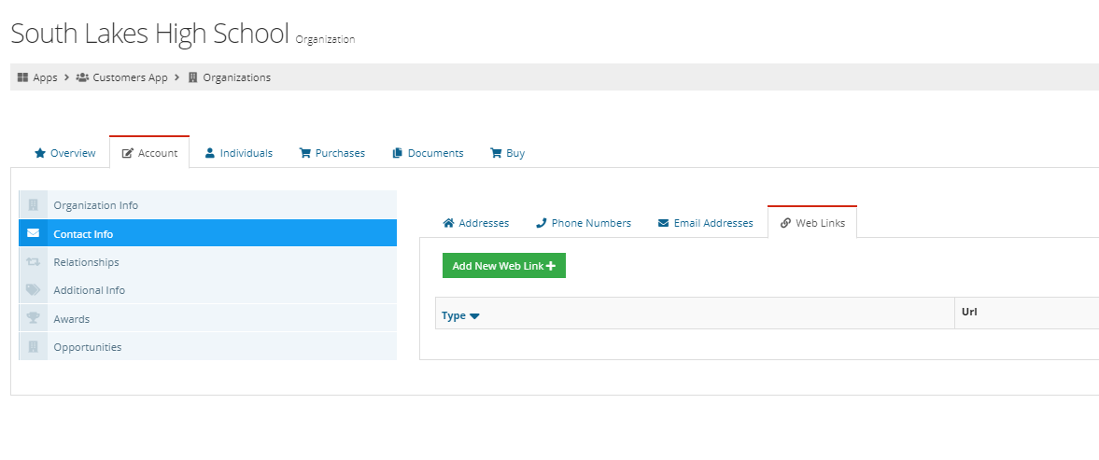

Correcting a Spelling Error on a Student Name

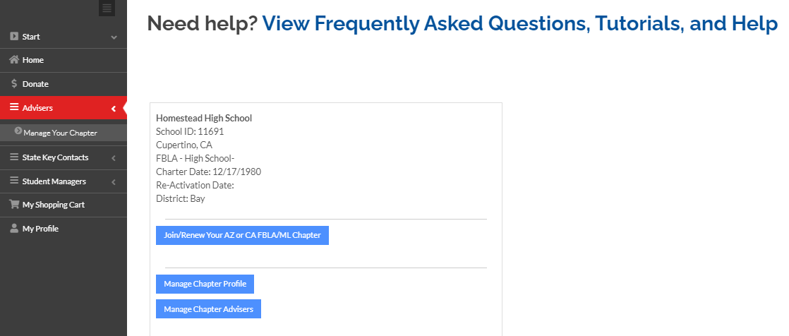
Click on Manage Your Chapter. Click on Manage Chapter Profile.

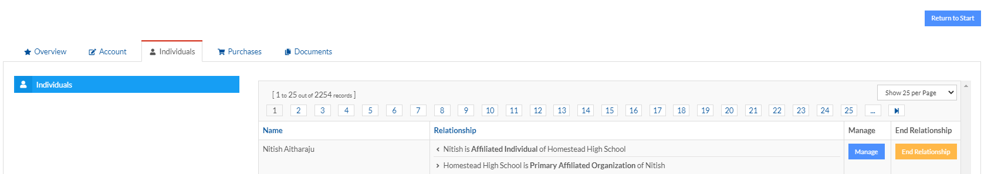

Click on the Individuals tab and the the Manage button on the line of the student that needs a spelling correction

Click on Account
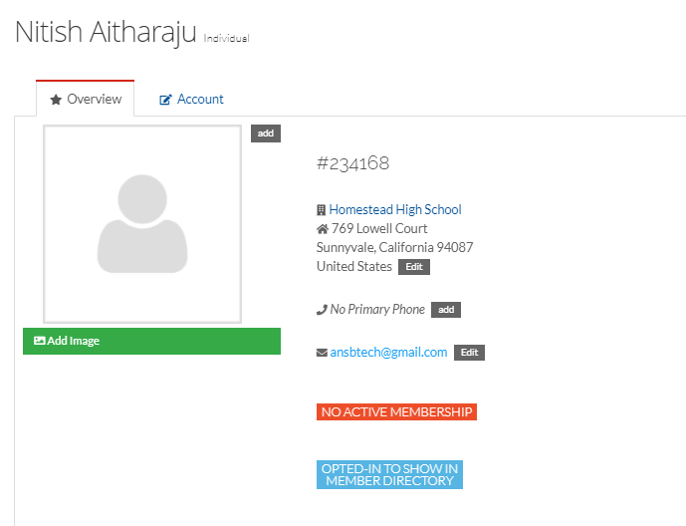

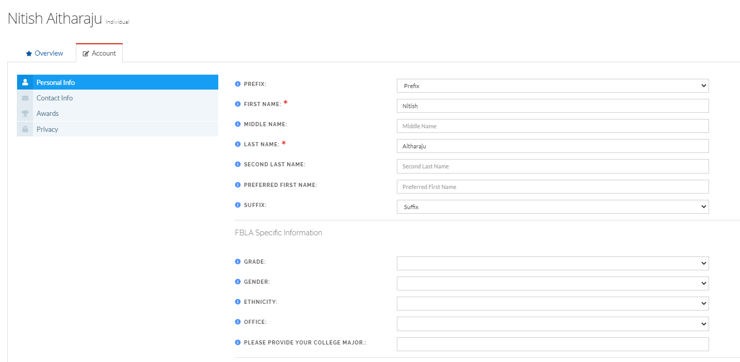

Type in name change and click on save at the bottom of the screen. You may change update the grade the same way. Just click on grade box – type in change and save.

Payments

W-9 Forms

Form Requests
Sometimes before a school can pay, they request a W-9 Form. We have copies of our W-9 available here.

Making a Credit Card Payment

- Sign into our my.fbla-pbl.org account
- Select “Advisers” and “Manage Your Chapter” from the left menu
- Select the make payments app
- Select All or however many members you want to pay for

Making Check Payment
Paying by Check
We accept check payments. Download a copy of your invoice and include it in the mailed envelope. Send checks to: FBLA-PBL, Inc., Attention Membership, P.O. Box 79063, Baltimore, MD, 21279

Viewing Paid members

List of all my active, paid members
- Sign into your my.fbla-pbl.org account
- Select “Advisers” and “Manage Your Chapter” from the left menu
- Select the blue “Your Chapter” button
- Choose the option on the list that says “View Paid Students and PD Members”
  - Note that this option loads data from a de-normalized dataset that is refreshed every 4 hours (3am, 7am, 11am, 3pm, 7pm, 11pm Eastern).
- It can be difficult to get a count with the way this roster page is formatted, but you can download the information onto a spreadsheet by selecting “Tools” then “Export to CSV”

