2023 OUTSTANDING CHAPTER
RECOGNITION AWARD

THIS DOCUMENT MUST BE HONESTLY COMPLETED TO BE CONSIDERED FOR THE OUTSTANDING CHAPTER RECOGNITION AWARD (THE TOP 10 WILL BE RECOGNIZED) AT THE 2023 FBLA STATE LEADERSHIP CONFERENCE AWARD CEREMONY. The purpose of this document is to obtain a better representation of Kansas FBLA’s Top Chapters as an entire chapter and not just as competitive event winners.

- Your chapter will receive 1 point for every activity.
- The Top 10 schools with accumulated points from winning events will receive the following points. (1st-20 pts, 2nd-18 pts, 3rd-16 pts, 4th-14 pts, 5th-12 pts, 6th-10 pts, 7th-8 pts, 8th-6 pts, 9th-4 pts & 10th-2 pts)
- Activity CANNOT be repeated to gain additional points. The same activity can only appear in ONE SECTION. Example—A Color Run to raise money for the March of Dimes—It must either appear under the March of Dimes Activity Section or Fundraising Activity Section.
- The time frame for eligible Activity: the end of the 2022 State Leadership Conference to the beginning of the 2023 State Leadership Conference.
- WITHIN EACH SECTION, PLEASE NUMBER AND DATE EACH EVENT TO HELP ENSURE PROPER POINTS ARE AWARDED.
- There is a limit of points given for a repeated activity in the same category – i.e. Concession Stand, speaking to Lion’s Club, Athletic Programs, Team photos.
- A chapter submitting this form must have an activity in at least 10 DIFFERENT CATEGORY EVENTS.
- This form must be electronically typed and submitted on March 17 to kansasfblaevents@gmail.com

NO LATE SUBMISSIONS WILL BE ACCEPTED!
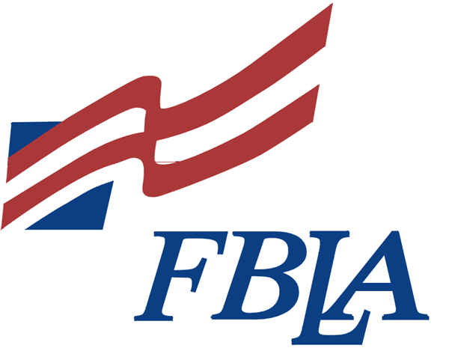
(LIMIT of 10 points awarded for repeat activity – i.e. - concession stand)

CHAPTER NAME:
CHAPTER ADVISER NAME:
CHAPTER ADVISER EMAIL:

Category Event | List | Point(s)
Accumulated Testing Points from the 2022 State Leadership Conference (The judge will do this)—(1st-20 pts, 2nd-18 pts, 3rd-16 pts, 4th-14 pts, 5th-12 pts, 6th-10 pts, 7th-8 pts, 8th-6 pts, 9th-4 pts & 10th-2 pts)
Community Service Activity
EX – Handed Food Out at the Food Pantry (9/25/22)
Participation in Service Member of the Month
(LIST NAME OF STUDENT & MONTH)

Fundraising Activity
EX – concession stand (9/10/22)
Leadership Activity
EX – Chapter Meeting (9/6/22)
March of Dimes Activity
EX – Sold Baby Feet (9/14/22)
Media Recognition
EX – Article in the Kansas Exchange (9/10/22) (NOT own Chapter’s social media accounts with recognition/posts)
Increased or Maintained Membership (Need # of members 2021-22 and # of members 2022-23)
Middle Level Awareness Activity
EX – Welcome Back Dance (8/25/22)
National Program Activity
Explain what your chapter did.
EX – FBLA Week
Monday—Share Your FBLA Story
Tuesday—Dress for Success Day
Wednesday—Speaker—Beth Dwyer
Thursday—Blue & Gold Day
Friday—History of FBLA Announcement

Other Examples: CTE Month, American Enterprise Day, Job Shadow Day, National Community Service Day, GO GREEN, Summer Starter, Shaping Success, Service Season, CTE Celebration, Champion +
Membership Drive
EX – Ice Cream Party (9/10/22)
School Service Activity
EX – All School Recycling Collection (9/22/22)
Business Achievement Award Completions
Contributor, Leader, Advocate, Capstone (Provide Student Name, level and business skill or content area if Advocate Level.)
Social Activity
EX – Scavenger Hunt (9/10/22)
2022 National Fall Leadership Conference Attendance (YES or NO)—DENVER, CO
(Include any awards won or recognitions received)
2022 National Leadership Conference Attendance (YES or NO)—CHICAGO, IL
(Include any awards won or recognitions received)
Member(s) Presented a Workshop at a FBLA Conference, OTHER than the Kansas Summer Leadership Seminar
(LIST NAME OF STUDENT(S), CONFERENCE AND WORKSHOP)

State Officer Candidate at the 2023 State Leadership Conference
(LIST NAME(S) AND OFFICE(S))
Submitted a Local Chapter Annual Business Report for the 2023 State Leadership Conference (YES or NO)
Recruited or Reactivated Chapters
(LIST CHAPTER(S))
Promoted FBLA to Other Schools Through Formal Presentations
(LIST SCHOOL(S) AND PRESENTER(S))
Hosted a 2023 District Conference
(YES or NO)
Have a National Officer 2022-2023
(LIST NAME & POSITION)
Have a National Officer Council Member, Regional Board Member or Kansas FBLA Active Membership Council Member
(LIST NAME(S) & TITLE(S))
Corporate Sponsor(s) for 2023 SLC
(LIST NAME AND $ AMOUNT)
EX – Solomon State Bank $125
Submitted Chapter of the Month Criteria (LIST THE MONTHS SUBMITTED)
Pin design(s) submitted by deadline for the 2022-2023 Year (YES or NO)
Chapter Social Media Account updated regularly (List Social Media Accounts)
EX – Facebook, Instagram
OTHER (Description)
(Place anything here that you do not feel belongs in the other categories)

