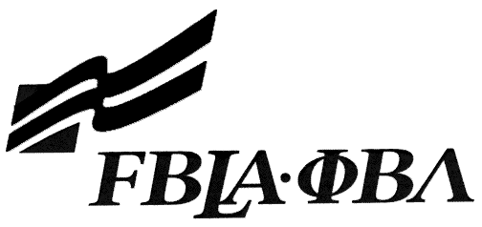 2019 Kansas FBLA Statement of Assurance
THIS DOCUMENT MUST BE TYPED
Check one: 3-D Animation (Statement of Assurance)
Broadcast Journalism (URL)
Business Ethics (URL)
Computer Game & Simulation Programming (Statement of Assurance and Necessary Materials)
Coding & Programming (Statement of Assurance and Necessary Materials)
Digital Video Production (Statement of Assurance and URL)
E-business (Statement of Assurance and URL)
Electronic Career Portfolio (Statement of Assurance and URL)
Graphic Design (Statement of Assurance and Necessary Materials)
Introduction to Business Presentation (URL)
Mobile Application Development (Statement of Assurance and Necessary Materials)
Public Service Announcement (Statement of Assurance and URL)
Publication Design (Statement of Assurance and Necessary Materials)
Website Design (Statement of Assurance and URL)

Provide the complete URL for Broadcast Journalism, Business Ethics, Digital Video Production, E-business, Electronic Career Portfolio, Introduction to Business Presentation, Public Service Announcement and Website Design. These events will be judged online. Make sure the URL link is valid through the State Leadership Conference. kansasfblaevents@gmail.com

KEY INFORMATION
State: | Kansas
School:
Website URL Address: (where appropriate—must have full address)
Member(s) Name:
Local Chapter Contact
Name:
Daytime/Cell Number:
Home E-mail:
I/We, the undersigned, attest that the design, creation, and implementation of the event are the original work of the above chapter member(s). I/we agree that this event may be linked, promoted, and used in any way by the national FBLA-PBL, Inc. for purposes of promoting the association. (Typed name is accepted for signature)
Name of Team Member |  | Name of Team Member
Name of Team Member |  | Adviser’s Name
Complete this Document Section for the Above Events if Applicable
Software Used:
Source of Information:
Copyright Notations
Instructions for Running Project:
Template(s) Used (source)

