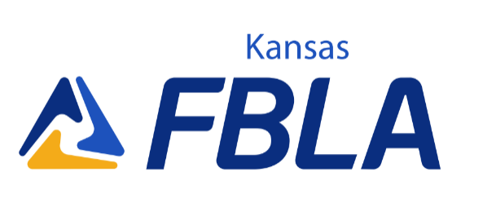
Quality Member Award- FBLA HS Division
The Kansas collegiate division of FBLA has proudly sponsored the Kansas FBLA Quality Member Award (QMA) for over 15 years. To receive the KS FBLA Quality Member Award (QMA), you must complete the requirements listed below. All activities must be FBLA related and completed between March 2022-February 2023. Check the column at the left when completed, and list the month, day, and year that you completed each task (example 3/31/22). Numbers 1-4 are required for consideration; members are highly encouraged to fill out as many activities applicable to them in the ‘optional’ section, and answer the two short response essay questions. FBLA Advisers must sign the form (OR send an email of approval to the FBLA Collegiate State Adviser) to be eligible. Current KS FBLA State Officers or National Officers are not eligible for this award.

Member Name: Member Grade:________________________
Member E-mail: Member Chapter: .
Adviser: . Adviser Signature:_______________________
Required

__ 1. Attend five local FBLA chapter meetings (in person or virtual) in the 2022-2023 year:

__ 2. Recruit two FBLA members:

__ 3. Organize or participate in one project for March of Dimes:
__ 4. List all the FBLA Conferences (in person or virtual) that you have attended while in FBLA (example: Districts, SLS (Summer Leadership Seminar), NFLC's (National Fall Leadership Conference), State Leadership Conference (SLC), National Leadership Conference, etc.)
Optional

Serve as an active member of a committee.
Committee: Date(s) of Participation:
Participate in an FBLA fundraising activity.
Activity: Date:
Participate in a school or community service project (NOT March of Dimes).
Project: Date:
Give a presentation involving FBLA.
Audience/Location: Date:
Participate in American Enterprise Day or FBLA Week project.
Project: Date:
Participate in one of the sections of the Chapter Challenge. Chapter Challenge Section(s):

Quality Member Award- FBLA HS Division

You must complete two short response essays. The required short response essay must be completed and one of the two optional short response essay questions. Each response must be 200-500 words (i.e. at least 200 words per question).

Elaborate on your role in these projects, not only what your chapter has done, if applicable.
The FBLA collegiate state officers will rank the applicants based on their involvement in the above activities and the quality of the short response essay questions (grammar, punctuation, structure, thought process, etc.)

Required Essay Question:
Since FBLA is a lifetime organization that begins with the Middle Level and ends with the Alumni & Professionals, “Why do you believe FBLA members should continue their membership in FBLA collegiate when they attend post-secondary education? Do you think FBLA collegiate would be a good fit for you; explain why or why not?”

*Note: we will not dock or award extra points if you say FBLA collegiate doesn't fit into your plan; it is the purpose to see why FBLA members do or do not join FBLA collegiate once they graduate.

Other Essay Questions (pick one):

Essay Question 1: What role do you and FBLA play in making a difference in your school and/or community? What value does a local FBLA chapter do for your community? What would the community be missing without the organization?

Essay Question 2: Why are ethics important in the corporate world? Using the FBLA Code of Ethics, explain how the organization influences students to become ethically responsible business leaders.

Send the completed and signed form along with your essay in a scanned PDF to:

Janice Akao, Kansas PBL State Adviser
ksadviser.cfbla@gmail.com

Forms must be emailed to Janice
by: February 15, 2023, 5:00 PM

