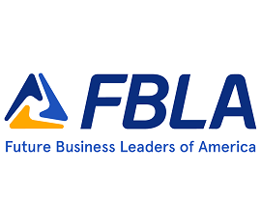
2023 KS FBLA State Pin Contest

Kansas FBLA will be holding a pin design contest for the 2023 NLC in Atlanta, GA. You can use our KS FBLA ‘theme’ Tomorrow’s Leaders Begin Today or the National FBLA theme One Association for Service, Education & Progress.
Each chapter can submit up to ‘two’ different designs for this contest. The pin can have up to six different colors (black does not count as a color) and be one inch square. Please be careful of copyright and it must be original.
The pin design must be submitted by DECEMBER 16, 2022 to State Adviser, Connie Lindell at conniefbla@gmail.com. Please include this entry form with your design(s). Once submitted, the pin designs will then be voted on at all district conferences and announced at the State Leadership Conference in Topeka, Kansas.

Design Members Name(s): ____________________________________________

Name of School: _________________________________________________

Adviser E-mail: _________________________________________________

General explanation of your design and/any symbols on your pin design:

2022 Winning State Pin Design—from Wellsville HS
